1. Download the IntelliJ from <https://www.jetbrains.com/idea/download/#section=windows>, and select any of the following (Ultimate or Community), in this documentation we will use community because it is free, open-source. Now click on download.



1. After downloading, open the installer. Start of by clicking next to continue.

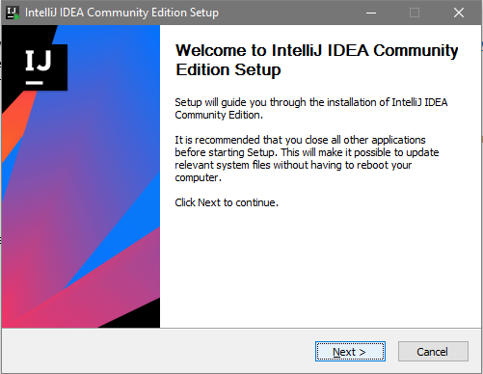

1. Select the directory where you want to install your IntelliJ.

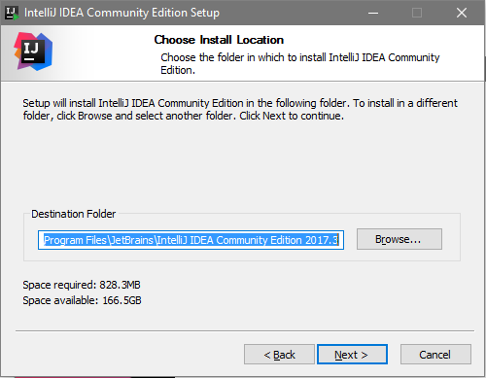

1. Select 64-bit launcher (It depends on your computer), then select any of the following (.java, .groovy, .kt) . Then select Download and install JRE if you don’t have JRE.

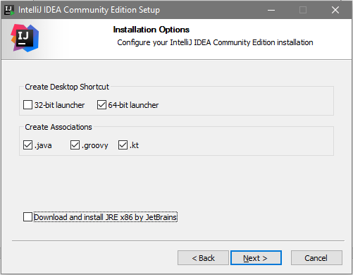

1. Now click on install.

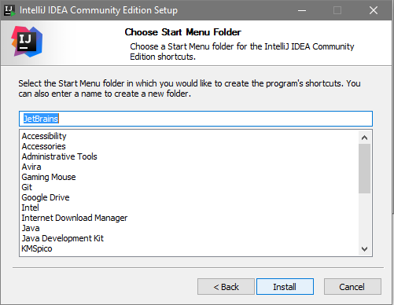

1. Wait for the program to be install, then select *Run IntelliJ IDEA Community Edition*, then click on Finish. Now you are ready to use IntelliJ.

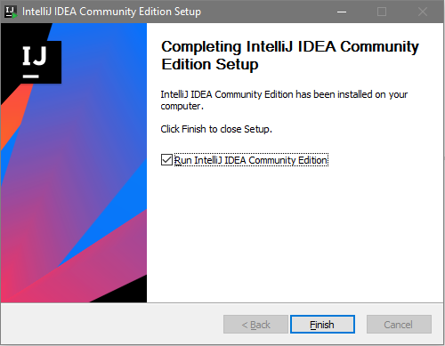

1. In the *“Complete Installation”* window select any of the following that best fits you.

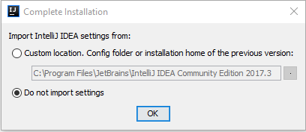

1. After clicking ok, the next window is about its’ privacy policy, just select *Accept* after the reading. Then your done, you can create new projects, import projects, open and etc.